SUMMARY OF ORGANIC REACTIONS

SECTION 1 - ALIPHATIC

Aldehydes and ketones

Type of reaction | Mechanism
1. oxidation (aldehydes only): aldehyde → carboxylic acid  reagents: potassium dichromate (K₂Cr₂O₇) in sulphuric acid (H₂SO₄)  conditions: warm under reflux  equation: R-CHO + [O] → R-COOH  observation: orange to green  to distinguish between aldehydes and ketones:  either:  add Fehling’s solution and heat  observation: blue solution to brick red precipitate  equation: R-CHO + 4OH⁻ + 2Cu²⁺ → R-COOH + Cu₂O + 2H₂O  or:  add Tollen’s reagent and heat  observation: colourless solution to silver mirror  equation: R-CHO + 2[Ag(NH₃)₂]⁺ + H₂O → RCOOH + 2Ag + 4NH₃ + 2H⁺ | n/a
2. reduction: carbonyl → alcohol  reagents: NaBH₄(aq)  conditions: room temperature  equation: R₁-CO-R₂ + 2[H] → R₁-CH(OH)-R₂ | Nucleophilic addition (required)
3. addition of HCN: carbonyl → hydroxynitrile  reagents: NaCN and HCl(aq)  conditions: room temperature  equation: R₁-CO-R₂ + HCN → R₁-C(CN)(OH)-R₂ | Nucleophilic addition (required)

Carboxylic acids and their salts

Type of reaction | Mechanism
1. acid-base  a) carboxylic acids with sodium hydroxide  reagent: NaOH  conditions: room temperature  equation: R-COOH(aq) + NaOH(aq) → R-COO⁻Na⁺(aq) + H₂O(l)  b) carboxylic acids with sodium carbonate  reagent: Na₂CO₃  conditions: room temperature  equation: 2R-COOH(aq) + Na₂CO₃(aq) → 2R-COO⁻Na⁺(aq) + CO₂(g) + H₂O(l)  observations: colourless gas evolved which turns limewater milky  c) carboxylate salts with acids  reagent: HCl(aq)  conditions: room temperature  equation: R-COO⁻(aq) + H⁺(aq) → R-COOH(aq) | n/a
2. esterification  reagents: any alcohol, concentrated sulphuric acid catalyst  conditions: heat and reflux  equation: R₁-COOH + R₂OH == R₁-COOR₂ + H₂O | Nucleophilic addition/  Elimination  (not required)

Esters

Type of reaction | Mechanism
hydrolysis  a) acid hydrolysis  reagent: concentrated H₂SO₄  conditions: heat under reflux  equation: R₁-COOR₂ + H₂O == R₁-COOH + R₂OH  b) alkaline hydrolysis (saponification)  reagent: NaOH(aq)  conditions: heat under reflux  equation: R₁-COOR₂ + NaOH == R₁-COO⁻Na⁺ + R₂OH | n/a

Acyl chlorides and acid anhydrides

Type of reaction | Mechanism
1. acylation using acyl chlorides  a) with water (to make carboxylic acids)  conditions: room temperature  equation: R-COCl + H₂O → R-COOH + HCl  observation: white misty fumes  b) with ammonia (to make amides)  conditions: room temperature  equation: R-COCl + NH₃ → R-CONH₂ + HCl  observation: white misty fumes  c) with alcohols (to make esters)  conditions: room temperature  equation: R₁-COCl + R₂-OH → R₁-COOR₂ + HCl  observation: white misty fumes  d) with primary amines (to make N-substituted amides)  conditions: room temperature  equation: R₁-COCl + R₂-NH₂ → R₁-CONHR₂ + HCl  observation: white misty fumes | Nucleophilic addition-elimination  (required)
2. acylation using acid anhydrides  a) with water (to make carboxylic acids)  conditions: room temperature  equation: R₁-COOCO-R₂ + H₂O → R₁-COOH + R₂-COOH  b) with ammonia (to make amides)  conditions: room temperature  equation: R₁-COOCO-R₂ + NH₃ → R₁-CONH₂ + R₂-COOH  c) with alcohols (to make esters)  conditions: room temperature  equation: R₁-COOCO-R₂ + R₃-OH → R₁-COO-R₃ + R₂-COOH  d) with primary amines (to make N-substituted amides)  conditions: room temperature  equation: R₁-COOCO-R₂ + R₃-NH₂ → R₁-CONH-R₃ + R₂-COOH | Nucleophilic addition-elimination  (not required)

Amines

Type of reaction | Mechanism
1. haloalkane → primary amine  reagents: haloalkane and excess ammonia  conditions: heat  equation: R-X + 2NH₃ → R-NH₂ + NH₄X  or  reagent: haloalkane and ammonia (1:1 ratio)  conditions: heat  equation: R-X + NH₃ → R-NH₂ + HX  2. haloalkane → secondary amine  reagents: haloalkane and ammonia (2:1 ratio)  conditions: heat  equation: 2R-X + NH₃ → R-NH-R + HX  or  reagents: haloalkane and primary amine  conditions: heat  equation: R₁-X + R₂-NH₂ → R₁-NH-R₂ + HX  3. haloalkane → tertiary amine  reagents: haloalkane and ammonia (3:1 ratio)  conditions: heat  equation: 3R-X + NH₃ → R₃N + HX  or  reagents: haloalkane and secondary amine  conditions: heat  equation: R₁-X + R₂-NH-R₃ → R₁R₂R₃N + HX  4. haloalkane → quartenary ammonium salt  reagents: haloalkane and ammonia (4:1 ratio)  conditions: heat  equation:  4R-X + NH₃ → [R₄N]⁺X⁻  or  reagents: haloalkane and secondary amine  conditions: heat  equation: R₁-X + R₂R₃R₄N → [R₁R₂R₃R₄N]⁺X⁻ | Nucleophilic substitution (required)
2. reduction: nitrile → primary amine  reagents: LiAlH₄ in dry ether  conditions: room temperature  equation: R-CN + 4[H] → R-CH₂NH₂ | n/a
3. acid-base:  a) amines with acids  equations: R₁-NH₂ + HCl → R₁-NH₃Cl  R₁R₂-NH + HCl → R₁R₂-NH₂Cl  R₁R₂R₃-N + HCl → R₁R₂R₃-NHCl  b) alkyl ammonium salts with alkalis  equations: R₁-NH₃Cl + NaOH → R₁-NH₂ + NaCl + H₂O  R₁R₂-NH₂Cl + NaOH → R₁R₂-NH + NaCl + H₂O  R₁R₂R₃-NHCl + NaOH → R₁R₂R₃-N + NaCl + H₂O | n/a

Amino Acids

Type of reaction | Mechanism
1. acid-base reactions of amino acids  a) with acids  reagents: HCl  conditions: room temperature  equation: R-CH(NH₂)-COOH + HCl → R-CH(NH₃⁺Cl⁻)-COOH  b) with alkalis  reagents: NaOH  conditions: room temperature  equation: R-CH(NH₂)-COOH + NaOH →R-CH(NH₂)-COO⁻Na⁺ + H₂O  2. condensation reactions of amino acids  conditions: DNA  equation: n R-CH(NH₂)-COOH → H-(NHCRHCO)_{n}-OH + (n-1) H₂O  3. hydrolysis of proteins  reagents: 6 moldm⁻³ HCl  conditions: heat, reflux  equation: H-(NHCRHCO)_{n}-OH + (n-1) H₂O + n HCl → n R-CH(NH₃⁺Cl⁻)-COOH | Nucleophilic addition-elimination  (not required)

Polymers

Type of reaction | Mechanism
1. Addition polymerisation (alkenes → polyalkenes)  conditions: high temperature, Ziegle-Natte catalyst  equation:  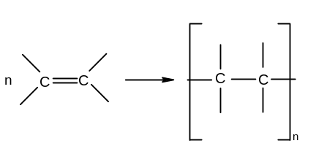  2. Condensation polymerisation  a) polyesters  dicarboxylic acid + diol → polyester  conditions: H₂SO₄, heat under reflux  equation:  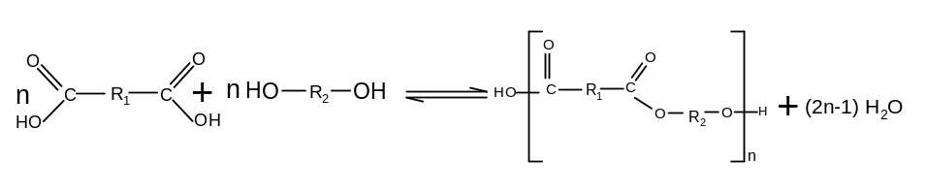  or  diacyl chloride + diol → polyester  conditions: room temperature  equation:  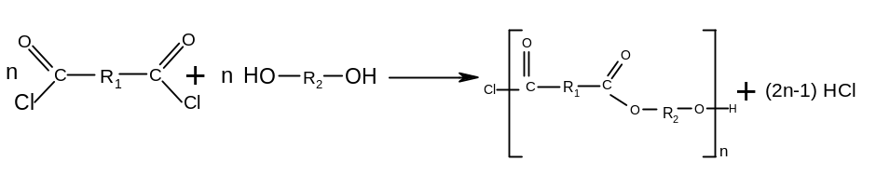  b) polyamides  dicarboxylic acid + diamine → polyamide  conditions: warm, reflux  equation:  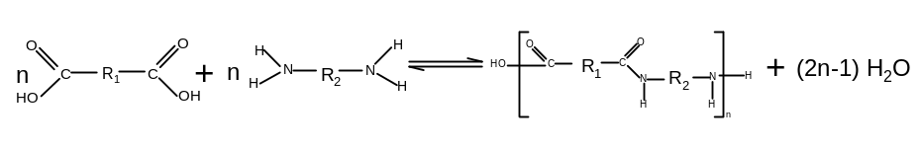  or  diacyl chloride + diamine → polyamide  conditions: room temperature  equation:  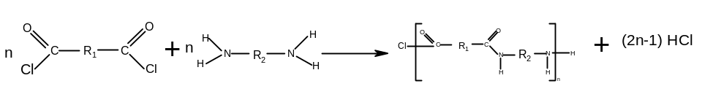 | Free radical addition  (not required)  Nucleophilic addition-elimination  (not required)
3. Hydrolysis of condensation polymers  a) polyesters  reagents: NaOH(aq)  conditions: heat  equation:  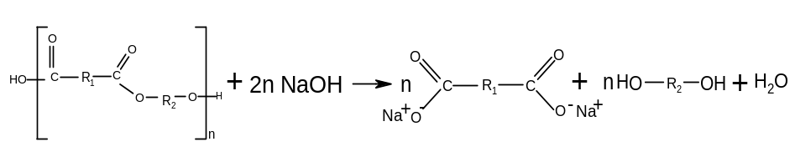  b) polyamides  reagents: HCl(aq)  conditions: heat  equation:  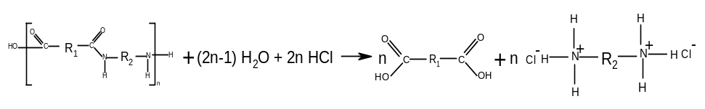 | n/a  n/a

SECTION 2 – AROMATIC

Type of reaction | Mechanism
1. nitration (benzene → nitrobenzene)  Reagent: conc HNO₃ in conc H₂SO₄  Conditions: 50-55ºC under reflux  Equation: C₆H₆ + HNO₃ → C₆H₅NO₂ + H₂O | Electrophilic substitution  (required)
2. alkylation (benzene → alkylbenzene)  Reagent: R-Cl with anyhdrous AlCl₃  Conditions: 50ºC under reflux  Equation: C₆H₆ + R-Cl → C₆H₅-R + HCl  OR  Reagent: alkene with anhydrous AlCl₃ and HCl  Equation: C₆H₆ + R₁R₂C=CR₁R₂ → C₆H₅CR₁R₂CR₃R₄ | Electrophilic substitution  (required)
3. acylation (benzene → phenylketone)  Reagent: R-COCl with anydrous AlCl₃  Conditions: 50ºC under reflux  Equation: C₆H₆ + R-COCl → C₆H₅COR + HCl | Electrophilic substitution  (required)
4. reduction (nitrobenzene → phenylamine)  Reagents: Sn in conc HCl  Conditions: heat under reflux  Equation: C₆H₅NO₂ + 6[H] → C₆H₅NH₂ + 2H₂O | n/a

